PCB Order Form
Buyer Information
Name | Anthony Ruiz |  |  | Email |  | anthony@quantumfocus.com
Address | QFI  2385 La Mirada Dr. Vista, USA, 92081
Telephone | 760-583-5485 | Fax |  |  | Web
Delivery Time | 10 working days |  |  | Payment |  |  | pay in advance

Order Description
File Name | Thermal Gerber.zip |  |  | layers |  | 2/4
Size | 182.86x129.21mm |  |  | Finish |  | HASL
Number | 10 |  |  | Thickness |  | 1.6mm
Express | Yes____ No √ |  |  | Shipment |  | EMS DHL_√___
Comments | 2oz copper
Top layer Artwork | 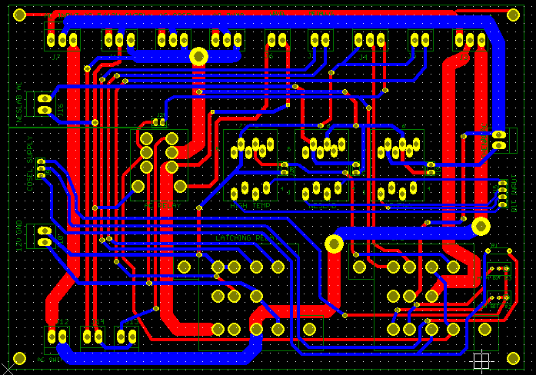
Unit Price | $205 | shipping | $60 |  | Paypal |  | $11
Total | $276
Notes/Remarks
- Shipping and banking charges are on buyer’s side
- Price are for from Beijing

Vendor: | 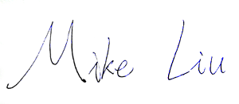 |  | Buyer

